DAY - 2 HACKERRANK PROBLEMS SOLVED

1.Utopian Tree

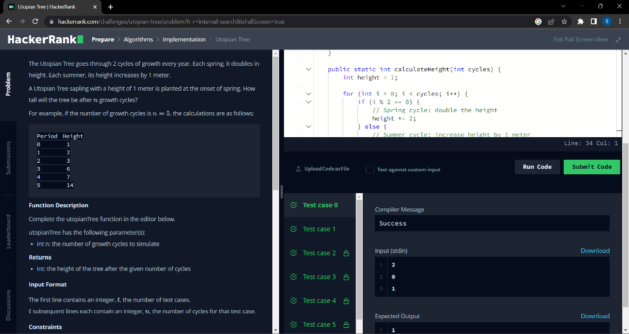

2.Triple Sum

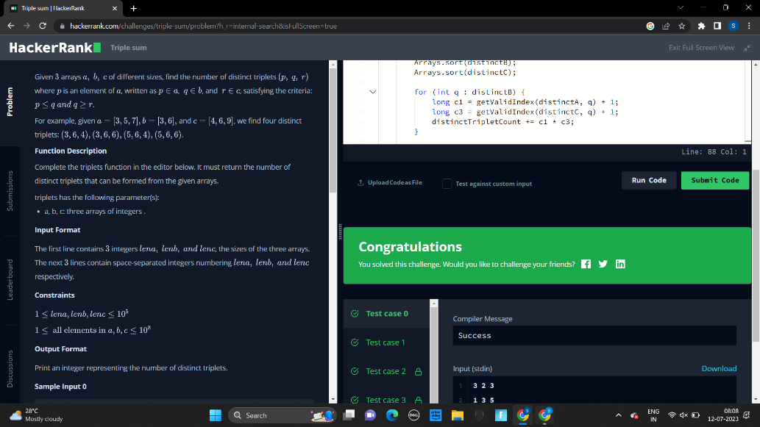

3.Seperate Number

